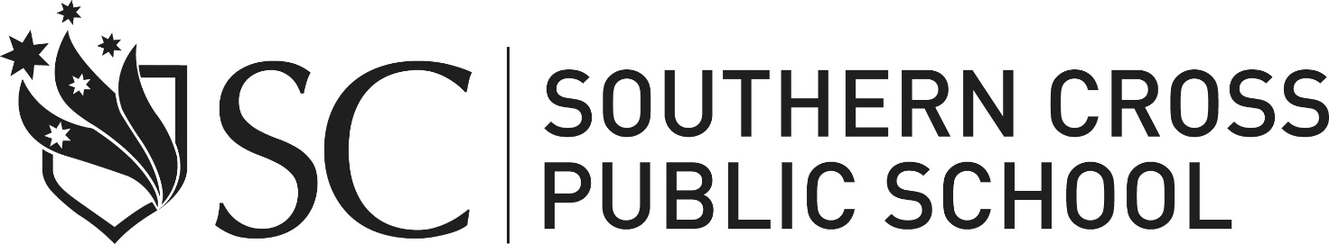

STUDENT ASSISTANCE SCHEME-Request for Assistance
Please complete this form as accurately as possible – one student per form

STUDENT DETAILS
Name:  Year Group: | Address:
FAMILY DETAILS

Parent/Carer: | Phone Contact:

PERSONAL FINANCIAL INFORMATION
Do you/your student receive any of the following (please tick)
- Pension | - Allowance for Isolated Children
- Benefit | - Family Allowance
- Abstudy | - Wage/Salary

SUPPORT INFORMATION
Any further information to support this request:

CONTRIBUTION
Contribution you can make to school costs: $

Would you be able to pay off the assistance requested? Yes No

ASSISTANCE REQUESTED

DETAILS OF REQUEST |  | COST OF  ITEMS | AMOUNT REQUESTED
Elective fees | Subject/s: | $  $  $  $ | $  $  $  $
Uniform  items |  | $  $  $ | $  $  $
Excursion  Other (eg sports representation) |  | $  $  $ | $  $  $
TOTAL |  | $ | $

NB: A maximum of 1/3 of mandatory curriculum excursion and costs is able to be provided. For further funding a referral to the Learning and Support Team is required.

- Assistance cannot be provided towards the School contribution.
Exemption from payment of this can be provided.

DECLARATION: I declare to the best of my knowledge that the information I have given is true and correct.

Date:

Signed: ____________________________________ (parent/guardian)

Please return in a sealed envelope addressed to The Principal,
Southern Cross Public School, 2-40 Chickiba Drive, East Ballina 2478

Principal’s Use Only | Amount requested | Amount Approved | Balance Owing by Parent
 | $ | $ | $

